

**MANAV RACHNA UNIVERSITY**

**TUPLE**

**1.** Write a Python program to create a tuple.

t1= ()

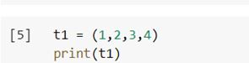

**2.** Write a Python program to create a tuple with different data types.

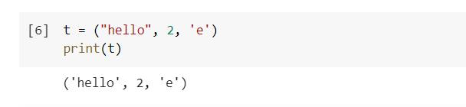

**3.** Write a Python program to create a tuple with numbers and print one item.

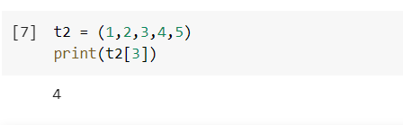

**4.** Write a Python program to unpack a tuple in several variables.

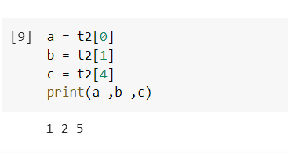

**5.** Write a Python program to add an item in a tuple.

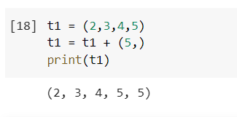

**6.** Write a Python program to convert a tuple to a string.

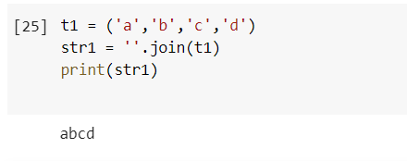

**7.** Write a Python program to get the 4th element and 4th element from last of a tuple

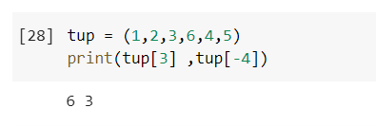

**8.** Write a Python program to create the colon of a tuple.

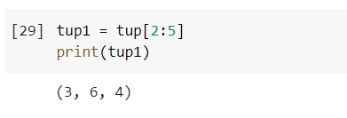

**9.** Write a Python program to find the repeated items of a tuple.

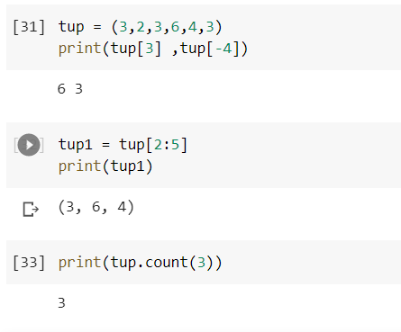

**10.** Write a Python program to check whether an element exists within a tuple.

**11.** Write a Python program to convert a list to a tuple.

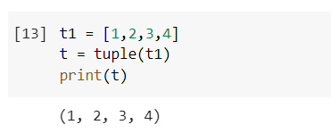

**12.** Write a Python program to remove an item from a tuple.

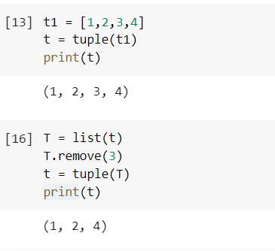

**13.** Write a Python program to slice a tuple

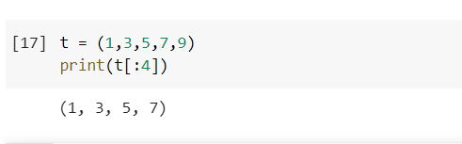

**14.** Write a Python program to find the index of an item of a tuple.

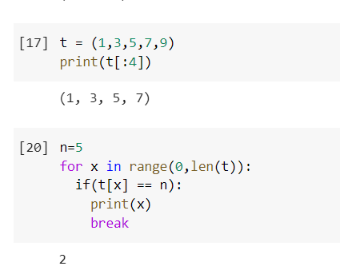

**15.** Write a Python program to find the length of a tuple.

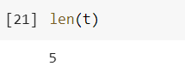

16. Write a Python program to reverse a tuple.

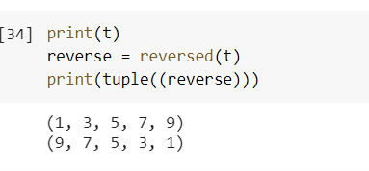

**List**

**1.** Write a Python program to sum all the items in a list.

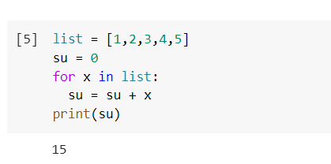

**2.** Write a Python program to multiplies all the items in a list.

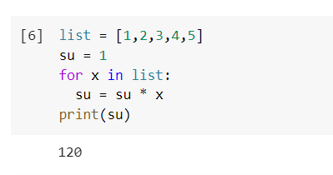

**3.** Write a Python program to get the largest number from a list

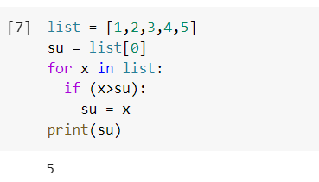

**4.** Write a Python program to get the smallest number from a list.

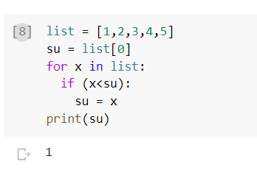

**5.** Write a Python program to count the number of strings where the string length is 2 or more and the first and last character are same from a given list of strings   
Sample List : ['abc', 'xyz', 'aba', '1221']  
Expected Result : 2

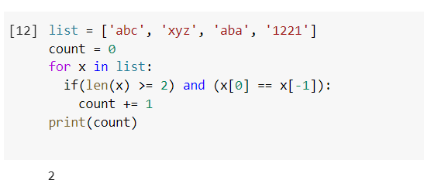

**6.** Write a Python program to get a list, sorted in increasing order by the last element in each tuple from a given list of non-empty tuples.    
Sample List : [(2, 5), (1, 2), (4, 4), (2, 3), (2, 1)]

Expected Result : [(2, 1), (1, 2), (2, 3), (4, 4), (2, 5)]

**7.**Write a Python program to remove duplicates from a list.

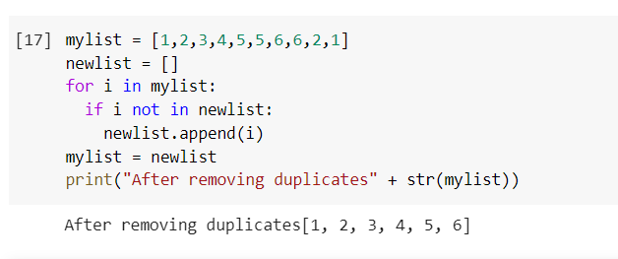

**8.**Write a Python program to check a list is empty or not.

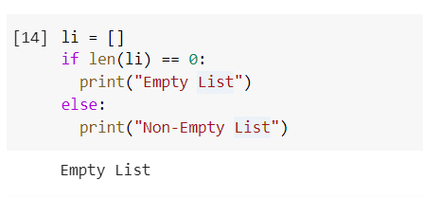

**9.**Write a Python program to clone or copy a list.

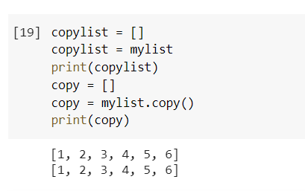

**10.**Write a Python program to find the list of words that are longer than n from a given list of words.

**11.**Write a Python function that takes two lists and returns True if they have at least one common member.

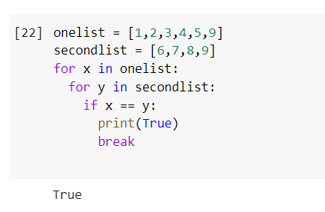

**12.**Write a Python program to print a specified list after removing the 0th, 4th and 5th elements.    
Sample List : ['Red', 'Green', 'White', 'Black', 'Pink', 'Yellow']  
Expected Output : ['Green', 'White', 'Black']  
